The idea of this project is to use a Microsoft Kinect, generic notebook, Verizon miFi satellite internet, 1/8 scale RC truck, arduino, GPS receiver, and other miscellaneous motor parts to create an autonomous RC car with GPS and Kinect tracking to drive on a road reaching a destination while avoiding obstacles.

This project is divided into two sections. The first section is the RC car itself and GPS navigation. In order to accomplish this, an Adruino connected to a GPS receiver will read coordinates to a small notebook embedded into the RC truck. This netbook will be connected to the internet through the Verizon miFi satellite receiver. Google maps will be loaded onto the netbook and the ardunio will read the GPS coordinates to Google maps through the USB serial port. Through Google maps, routes will be created and updated to the Arduino. A servo connected to the PWM pins on the Arduino will be used to guide in steering connected to an H-bridge to control speed and direction. Research into this has shown early prototypes in development but without real-time online Google mapping.

The second part of this project is integrating the Kinect device. This will also be connected to the netbook. The notebook’s main purpose will be the Microsoft Kinect because of the minimum requirements needed for 3-D mapping. Minimum system requirements must be met while keeping cost down as well. Research into this has shown previous projects of the detection of still and moving objects. Ultimately combining these previous ideas into the GPS tracked RC vehicle has not been done and through research has shown to be currently feasible.

Because Google maps is limited in detail, the Kinect is needed in order to process smaller detail such as obstacles. The Kinect itself will handle real-time obstacles such as cars passing. Fortunately, the Kinect can also process colors through a separate RGB-D sensor. This will allow to read shapes and colors in order to detect large objects such as stop signs and stop accordingly. The Kinect can measure distances through its 3-D mapping and also help with overcoming obstacles.

The GPS tracking with the Arduino will handle long range obstacles such as preparing for a turn and reaching a destination. The open-source information available on Google allows for GPS coordinate interaction.

A Ford F-150 1/8 scale RC car will be used in this project. The real time GPS tracking will be used through Google maps. The GPS module used will be a Fastrax UP501 GPS module. This device is NMEA compatible and can interact with Google maps SQL databases. Google Maps will be accessed through the internet with a Verizon miFi satellite receiver. In order to control the direction of the RC truck, a servo connected to an Arduino will be used. Slight modifications to the body of the RC truck will be required. A development Microsoft Kinect will be needed to design the software for 3-D mapping. The notebook will be a Gateway NE56R34u. These carry sufficient power to run the Kinect while keeping costs low.

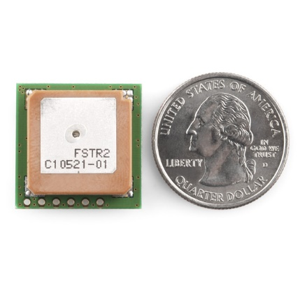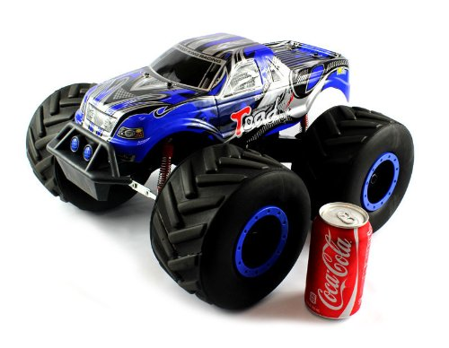

Left: 1/8 Scale RC vehicle, Right: GPS module.

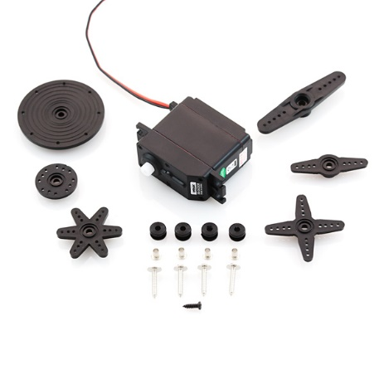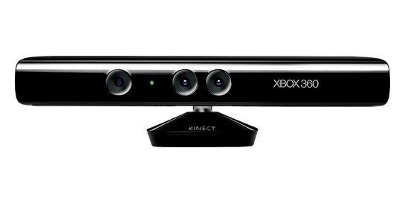

Left: Servo equipment, Right: Microsoft Kinect

In order to achieve the task of building this automatous car, funding is need to purchase the required items. This table shows a breakdown of the components needed:

|  |  |
| --- | --- |
| Microsoft Kinect for Windows | $300 |
| Netbook | $400 |
| Arduino | $30 |
| Servo | $20 |
| RC Truck (1/10 scale) | $150 |
| Misc Parts | $100 |
| Total | | **$1000** |